Tab 1

INTRODUCTION 2
DEGREE-WISE DISTRIBUTION 3
COMPUTER SCIENCE 6
Hybrid companies 6
Trends 6
ECONOMICS 7
Hybrid companies 7
Trends 7
ECONOMICS & FINANCE 9
Hybrid companies 9
Trends 9
PSYCHOLOGY 11
Hybrid companies 11
Trends 11
POLITICAL SCIENCE 13
Hybrid companies 13
Trends 13
PPE 14
Hybrid companies 14
Trends 14
ENGLISH 15
Hybrid companies 15
Trends 15
ENGLISH & MEDIA STUDIES 16
Hybrid companies 16
Trends 16
SOCIOLOGY & ANTHROPOLOGY 17
Trends 17

INTRODUCTION
This resource provides an analysis of the 2024–25 placement outcomes for graduating students. It maps the relationship between students’ degrees and the sectors in which they have been placed. By consolidating this information, the document aims to provide a clear picture of sectoral trends, degree-specific career pathways, and areas of overlap between disciplines.

The purpose of this resource is to:
- Provide students with an evidence-based understanding of how their academic degree can translate into employment opportunities.
- Identify patterns in degree-wise placements.
- Support current students in navigating placement options with greater clarity.
- Serve as a long-term reference for students in earlier years of study, many of whom often lack visibility into the career scope of their chosen degree.

The data analysed in this resource was drawn from the 2024–25 placement records.

Sector Mapping: Each student’s hiring company was mapped to its corresponding sector(s) based on the Placement Committee’s sector guidebook. The classification does not reflect the specific job function performed by the student, but the sector that the company operates in.

Many companies operate across multiple domains. Where relevant, a company was assigned to more than one sector. For example, a single placement may count under both Hospitality and Human Resources.

Hybrid Category: To ensure that no individual placement is double-counted across multiple sectors, companies operating in more than one sector have been grouped under a single “Hybrid” category. For each degree, the specific hybrid companies and their sectoral combinations are detailed within the respective section.

Visualisation: For each degree, two forms of representation are provided:
- A table summarising degree-wise sector distribution.
- A chart to visualise the degree’s placement distribution. Charts were not created for degrees with fewer placed students, to avoid overinterpretation of very small sample sizes. However, all degree data is fully represented in the tables.

Key Findings: Each degree section concludes with a summary of the major placement trends observed, emphasising recurring sectors and highlighting cross-sector opportunities.

DEGREE-WISE DISTRIBUTION

Degree | Total placed | Sector | Students in sector | % of degree
COMPUTER SCIENCE | 24 | Consulting | 8 | 33.33%
COMPUTER SCIENCE | 24 | IT & Engineering | 5 | 20.83%
COMPUTER SCIENCE | 24 | BFSI | 2 | 8.33%
COMPUTER SCIENCE | 24 | Logistics & Operations | 1 | 4.17%
COMPUTER SCIENCE | 24 | Development & Public Policy | 1 | 4.17%
COMPUTER SCIENCE | 24 | Healthcare & Pharmaceuticals | 1 | 4.17%
COMPUTER SCIENCE | 24 | Retail & E-Commerce | 1 | 4.17%
COMPUTER SCIENCE | 24 | Hybrid | 5 | 20.83%
COMPUTER SCIENCE & ENTREPENEURSHIP | 4 | BFSI | 2 | 50.00%
COMPUTER SCIENCE & ENTREPENEURSHIP | 4 | Consulting | 2 | 50.00%
COMPUTER SCIENCE & MATHEMATICS | 3 | Consulting | 2 | 66.67%
COMPUTER SCIENCE & MATHEMATICS | 3 | Logistics & Operations | 1 | 33.33%
ECONOMICS | 38 | Consulting | 17 | 44.74%
ECONOMICS | 38 | Development & Public Policy | 7 | 18.42%
ECONOMICS | 38 | BFSI | 4 | 10.53%
ECONOMICS | 38 | Education | 1 | 2.63%
ECONOMICS | 38 | Social Media & Content Creation | 1 | 2.63%
ECONOMICS | 38 | Healthcare & Pharmaceuticals | 1 | 2.63%
ECONOMICS | 38 | Retail & E-Commerce | 1 | 2.63%
ECONOMICS | 38 | Hybrid | 6 | 15.79%
ECONOMICS & FINANCE | 83 | Consulting | 31 | 37.35%
ECONOMICS & FINANCE | 83 | BFSI | 23 | 27.71%
ECONOMICS & FINANCE | 83 | Development & Public Policy | 8 | 9.64%
ECONOMICS & FINANCE | 83 | IT & Engineering | 3 | 3.61%
ECONOMICS & FINANCE | 83 | FMCG | 1 | 1.20%
ECONOMICS & FINANCE | 83 | Energy | 1 | 1.20%
ECONOMICS & FINANCE | 83 | Healthcare & Pharmaceuticals | 1 | 1.20%
ECONOMICS & FINANCE | 83 | Social Media & Content Creation | 1 | 1.20%
ECONOMICS & FINANCE | 83 | Hybrid | 14 | 16.87%
ECONOMICS & HISTORY | 1 | Sales & Marketing | 1 | 100.00%
PSYCHOLOGY | 37 | Consulting | 10 | 27.03%
PSYCHOLOGY | 37 | Sales & Marketing | 3 | 8.11%
PSYCHOLOGY | 37 | Development & Public Policy | 3 | 8.11%
PSYCHOLOGY | 37 | Education | 2 | 5.41%
PSYCHOLOGY | 37 | BFSI | 2 | 5.41%
PSYCHOLOGY | 37 | Human Resources | 1 | 2.70%
PSYCHOLOGY | 37 | Social Media & Content Creation | 1 | 2.70%
PSYCHOLOGY | 37 | Healthcare & Pharmaceuticals | 1 | 2.70%
PSYCHOLOGY | 37 | IT & Engineering | 1 | 2.70%
PSYCHOLOGY | 37 | Energy | 1 | 2.70%
PSYCHOLOGY | 37 | Retail & E-Commerce | 1 | 2.70%
PSYCHOLOGY | 37 | Hybrid | 11 | 29.73%
PSYCHOLOGY & PHILOSOPHY | 1 | Hybrid (Education + Social Media & Content) | 1 | 100.00%
POLITICAL SCIENCE | 16 | Consulting | 4 | 25.00%
POLITICAL SCIENCE | 16 | Development & Public Policy | 2 | 12.50%
POLITICAL SCIENCE | 16 | BFSI | 1 | 6.25%
POLITICAL SCIENCE | 16 | Logistics & Operations | 1 | 6.25%
POLITICAL SCIENCE | 16 | Healthcare & Pharmaceuticals | 1 | 6.25%
POLITICAL SCIENCE | 16 | Hybrid | 7 | 43.75%
POLITICS, PHILOSOPHY, ECONOMICS | 13 | Consulting | 4 | 30.77%
POLITICS, PHILOSOPHY, ECONOMICS | 13 | Sales & Marketing | 1 | 7.69%
POLITICS, PHILOSOPHY, ECONOMICS | 13 | Social Media & Content Creation | 1 | 7.69%
POLITICS, PHILOSOPHY, ECONOMICS | 13 | BFSI | 1 | 7.69%
POLITICS, PHILOSOPHY, ECONOMICS | 13 | Development & Public Policy | 1 | 7.69%
POLITICS, PHILOSOPHY, ECONOMICS | 13 | Energy | 1 | 7.69%
POLITICS, PHILOSOPHY, ECONOMICS | 13 | Hybrid | 4 | 30.77%
ENGLISH | 6 | Social Media & Content Creation | 1 | 16.67%
ENGLISH | 6 | Consulting | 1 | 16.67%
ENGLISH | 6 | Development & Public Policy | 1 | 16.67%
ENGLISH | 6 | Retail & E-Commerce | 1 | 16.67%
ENGLISH | 6 | Hybrid | 2 | 33.33%
ENGLISH & MEDIA STUDIES | 9 | Sales & Marketing | 3 | 33.33%
ENGLISH & MEDIA STUDIES | 9 | Social Media & Content Creation | 2 | 22.22%
ENGLISH & MEDIA STUDIES | 9 | Consulting | 1 | 11.11%
ENGLISH & MEDIA STUDIES | 9 | Hybrid | 3 | 33.33%
ENGLISH & CREATIVE WRITING | 2 | Social Media & Content Creation | 1 | 50.00%
ENGLISH & CREATIVE WRITING | 2 | Hybrid (Education + Sales & Marketing) | 1 | 50.00%
HISTORY | 2 | Development & Public Policy | 1 | 50.00%
HISTORY | 2 | Hybrid (Education + Development & Public Policy) | 1 | 50.00%
HISTORY & INTERNATIONAL RELATIONS | 1 | Education | 1 | 100.00%
SOCIOLOGY & ANTHROPOLOGY | 5 | Social Media & Content Creation | 3 | 60.00%
SOCIOLOGY & ANTHROPOLOGY | 5 | Consulting | 1 | 20.00%
SOCIOLOGY & ANTHROPOLOGY | 5 | Sales & Marketing | 1 | 20.00%
BIOLOGY | 3 | Consulting | 2 | 66.67%
BIOLOGY | 3 | Hybrid (Sales & Marketing + BFSI) | 1 | 33.33%

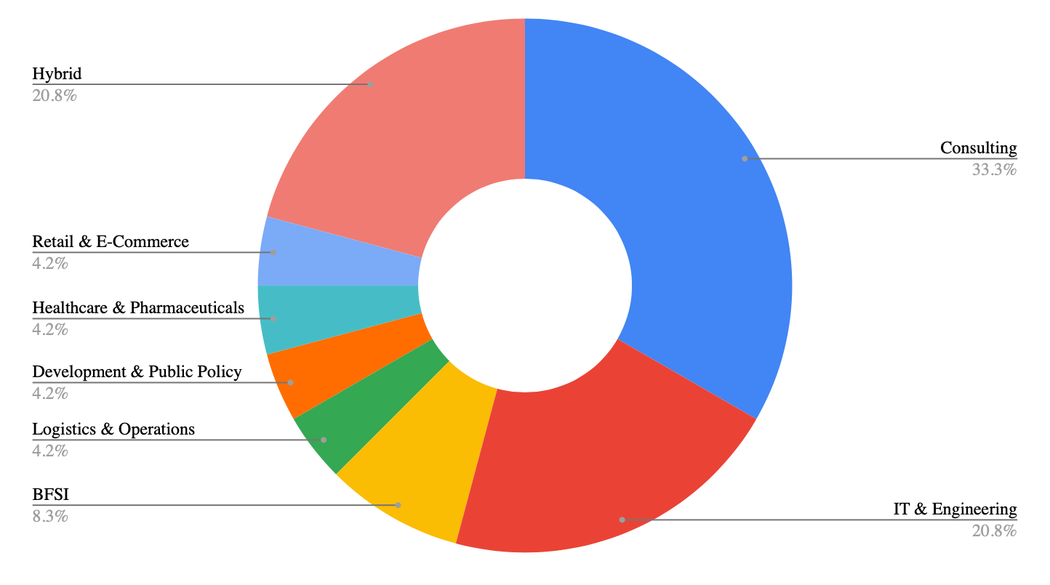
COMPUTER SCIENCE

Hybrid companies
- Firstsource Solutions Limited (Human Resources + IT & Engineering + Sales & Marketing + Logistics & Operations)
- Make My Trip (Sales & Marketing + Hospitality & Tourism + Human Resources)
- Fractal Analytics (Consulting + IT & Engineering)
- Tata AIA Life Insurance Company (Sales & Marketing + Logistics & Operations)

Trends
- Consulting is the leading sector for Computer Science majors, attracting 33.3% of students.
- IT & Engineering is the next major sector, with 20.8% students.
- Hybrid placements are significant: companies like Fractal Analytics and Firstsource Solutions offer cross-sector exposure (e.g., combining consulting, IT, sales & marketing, HR, and logistics).
- Smaller sectors include BFSI, Logistics, Development, Healthcare, Retail, highlighting the degree’s flexibility.
- Computer Science majors are not limited to purely technical pathways, they’re highly represented in consulting and hybrid roles, suggesting strong versatility and adaptability.

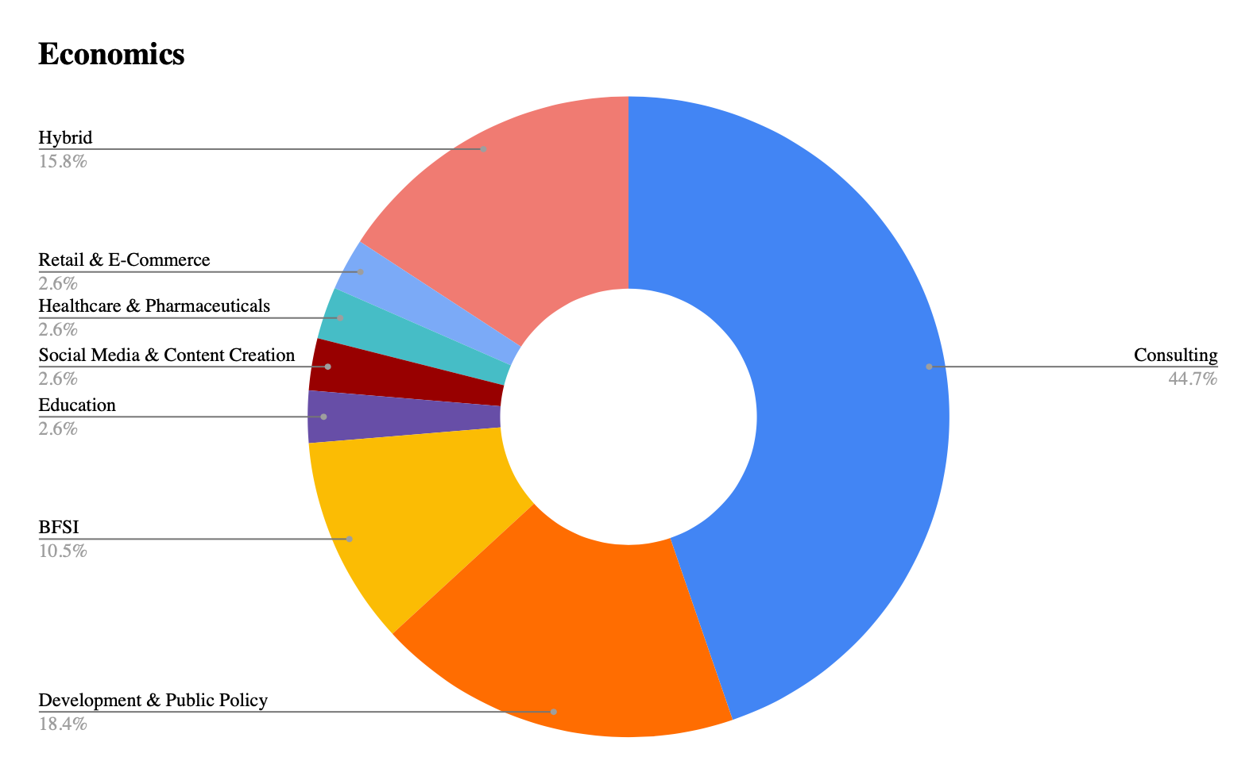
ECONOMICS

Hybrid companies
- Genpact (BFSI + Human Resources)
- Make My Trip (Sales & Marketing + Hospitality & Tourism + Human Resources)
- Tata AIA Life Insurance Company (Sales & Marketing + Logistics & Operations)
- Big Red Education (Education + Sales & Marketing)
- ITC Limited (FMCG + Human Resources + Hospitality & Tourism)
- Aviotron Aerospace Pvt.Ltd (Education + Sales & Marketing + Social Media & Content Creation + Aerospace)

Trends
- Consulting dominates placements, with 44.7% of Economics majors entering the sector.
- Development is the second-most popular field (18.4%).
- Hybrid roles attract 15.8%, with companies like Genpact, ITC, and Avitotron Aerospace offering cross-sector opportunities that span HR, FMCG, Education, Sales & Marketing, etc.
- BFSI is another strong destination.
- Smaller sectors (Education, Social Media, Healthcare, Retail at 2.6% each) show the degree’s reach into emerging/non-traditional areas.
- Economics graduates are strongly sought after in consulting and policy, while hybrid placements highlight their adaptability in multidisciplinary environments.

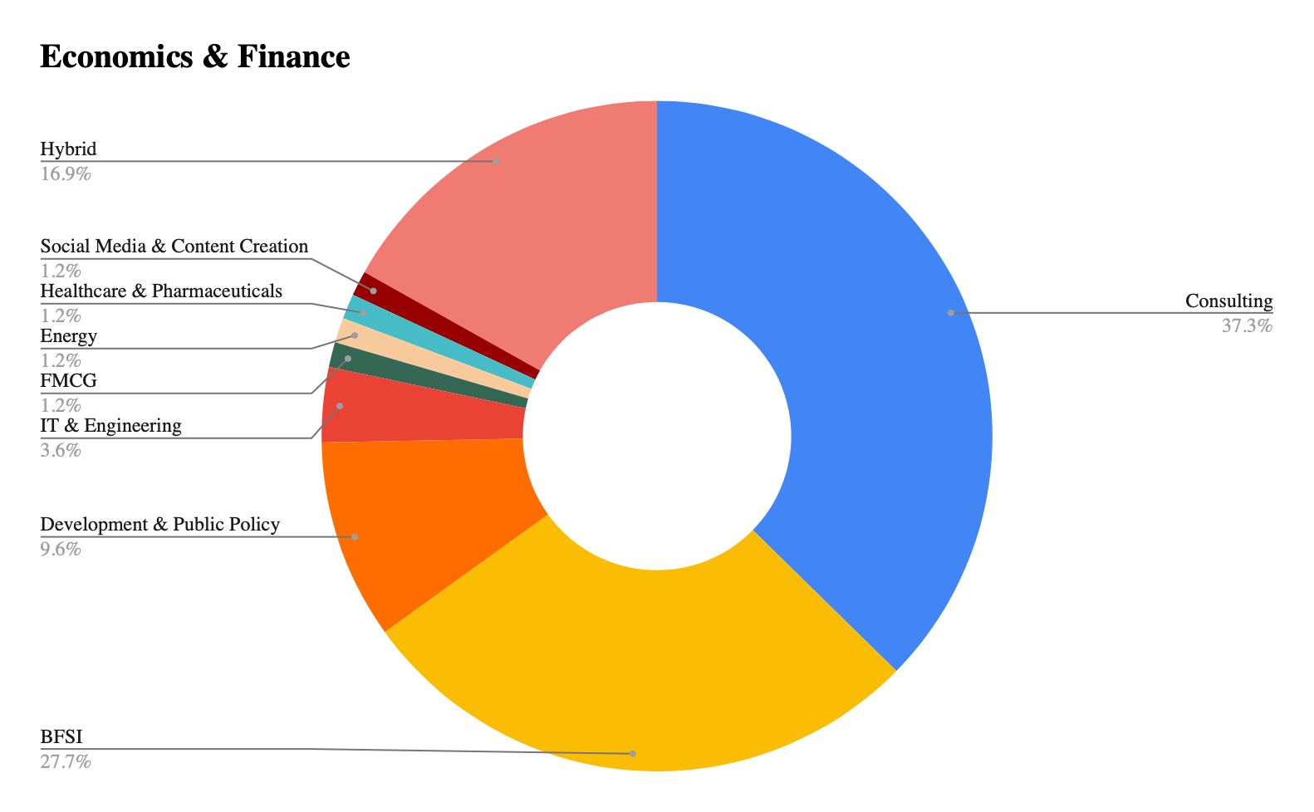
ECONOMICS & FINANCE

Hybrid companies
- Tata AIA Life Insurance Company (Sales & Marketing + Logistics & Operations)
- Hindustan Unilever (FMCG + Sales & Marketing)
- Genpact (BFSI + Human Resources)
- Flipkart (Retail & E-Commerce + Consulting)
- Clix Capital (Logistics & Operations + BFSI)
- Gerson Lehrman Group, Inc. (Consulting + Human Resources)
- Value Research (Sales & Marketing + BFSI)
- Kapable (Education + Human Resources)
- Make My Trip (Sales & Marketing + Hospitality & Tourism + Human Resources)

Trends
- Consulting (37.3%) is the largest destination for Economics & Finance majors.
- BFSI (27.7%) comes in as a very strong second, reflecting the degree’s clear alignment with finance-driven career paths.
- Hybrid opportunities (16.9%) are also significant, with firms like Tata AIA, Hindustan Unilever, and Flipkart offering cross-sector placements spanning BFSI, FMCG, Consulting, and more.

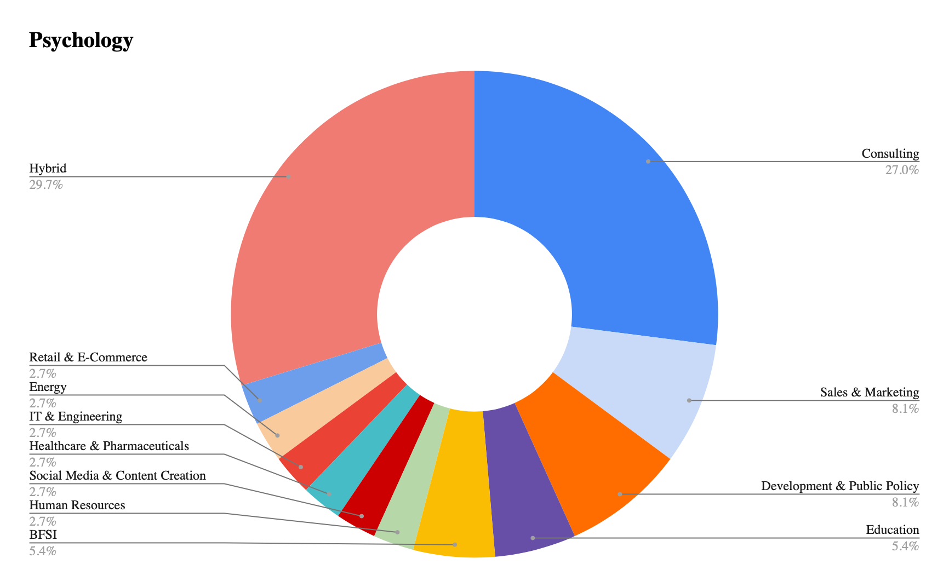
PSYCHOLOGY

Hybrid companies
- Make My Trip (Sales & Marketing + Hospitality & Tourism + Human Resources)
- OneSource (Healthcare & Pharmaceuticals + Sales & Marketing)
- learn with leaders (Sales & Marketing + Social Media & Content Creation + Education)
- Firstsource Solutions Limited (Human Resources + IT & Engineering + Sales & Marketing + Logistics & Operations)
- Essai (Education + Social Media & Content Creation)
- Clix Capital (Logistics & Operations + BFSI)

Trends
- Consulting (27%) emerges as the leading sector for Psychology majors.
- Hybrid opportunities (29.7%) form an even larger share, highlighting that Psychology students are being hired into diverse, cross-sector roles.
- Sales & Marketing (8.1%) and Development & Public Policy (8.1%) are second highest, reflecting the degree’s alignment with behavioural understanding.
- Psychology students demonstrate the broadest career versatility, with a balance between specialised domains, while hybrid placements underscore their interdisciplinary fit across industries.

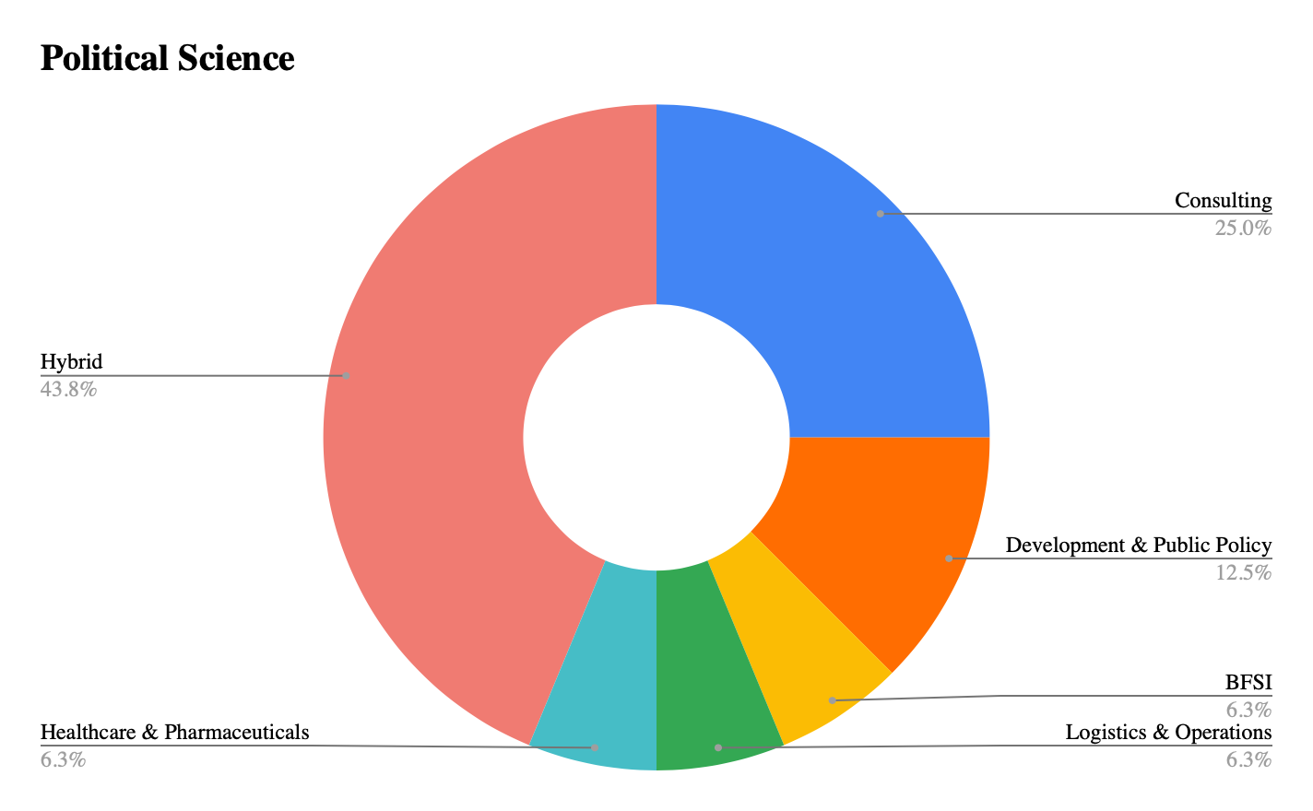
POLITICAL SCIENCE

Hybrid companies
- Ace International LLP (FMCG + Sales & Marketing)
- NIIT (Sales & Marketing + Social Media & Content Creation + Education)
- Clix Capital (Logistics & Operations + BFSI)
- Tasanaya Hospitality (Human Resources + Consulting + FMCG)

Trends
- Hybrid roles dominate (43.8%), the largest share across all degrees, showing that Political Science majors are valued for their ability to contribute across multiple sectors simultaneously.
- Consulting (25%) comes next.
- Other sectors such as Healthcare & Pharmaceuticals, BFSI, and Logistics & Operations (6.3%) indicate the growing diversification of Political Science careers beyond traditional fields.
- Political Science graduates show the highest inclination towards hybrid, interdisciplinary careers, combining elements of Consulting, FMCG, Education, and BFSI with their core strengths in policy and analysis.

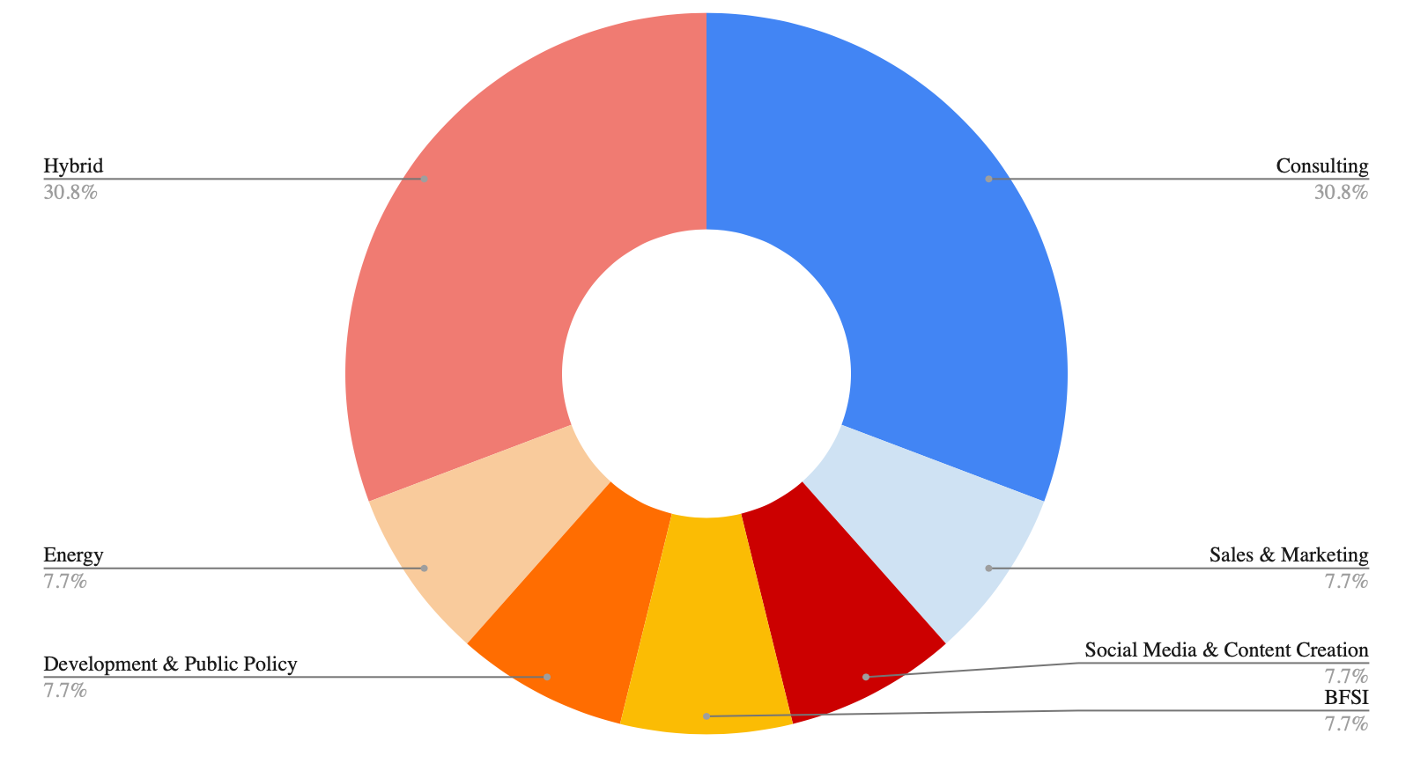
PPE

Hybrid companies
- Tata AIA Life Insurance Company (Sales & Marketing + Logistics & Operations)
- Tads Education (Education + Sales & Marketing)
- Jamboree Education (Social Media & Content Creation + Education)
- Big Red Education (Education + Sales & Marketing)

Trends
- Consulting and Hybrid careers dominate equally (30.8% each), indicating that PPE graduates are highly versatile.
- Other sectors such as Sales & Marketing, Social Media & Content Creation, BFSI, Energy, and Development & Public Policy are evenly represented (7.7%), reflecting diverse career outcomes.
- PPE majors show an inclination towards education-linked hybrid roles, with companies combining education with sales, marketing, and content creation.
- PPE graduates are balanced generalists, excelling in consulting and hybrid roles while also diversifying into sectors like BFSI, energy, and development.

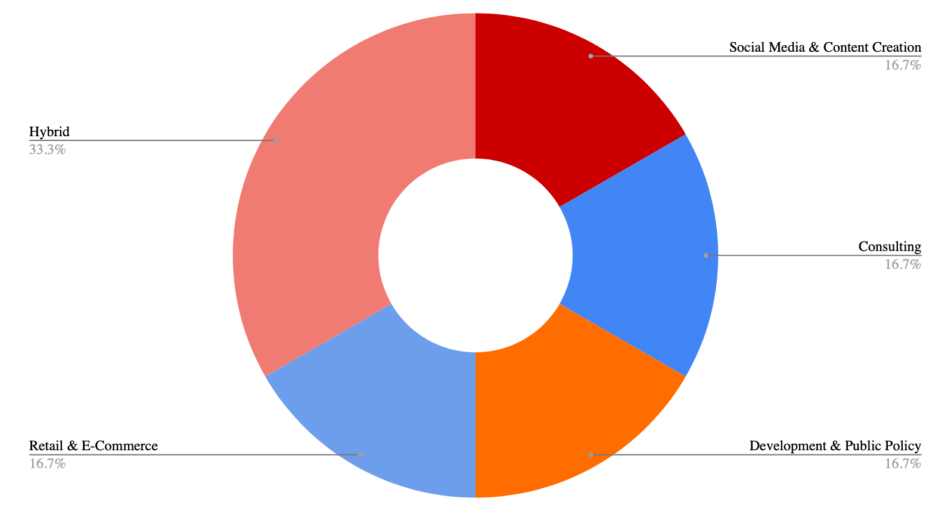
ENGLISH

Hybrid companies
- learn with leaders (Sales & Marketing + Social Media & Content Creation + Education)
- Jamboree Education (Social Media & Content Creation + Education)

Trends
- Hybrid roles dominate (33.3%), showing that English graduates are most drawn to multidisciplinary opportunities that combine education, social media, sales & marketing, and content creation.
- English majors have strong alignment with creative and communication-heavy industries.
- The remaining sectors are evenly represented at 16.7% each across Social Media & Content Creation, Consulting, Retail & E-Commerce, and Development & Public Policy, reflecting the versatility of English majors.

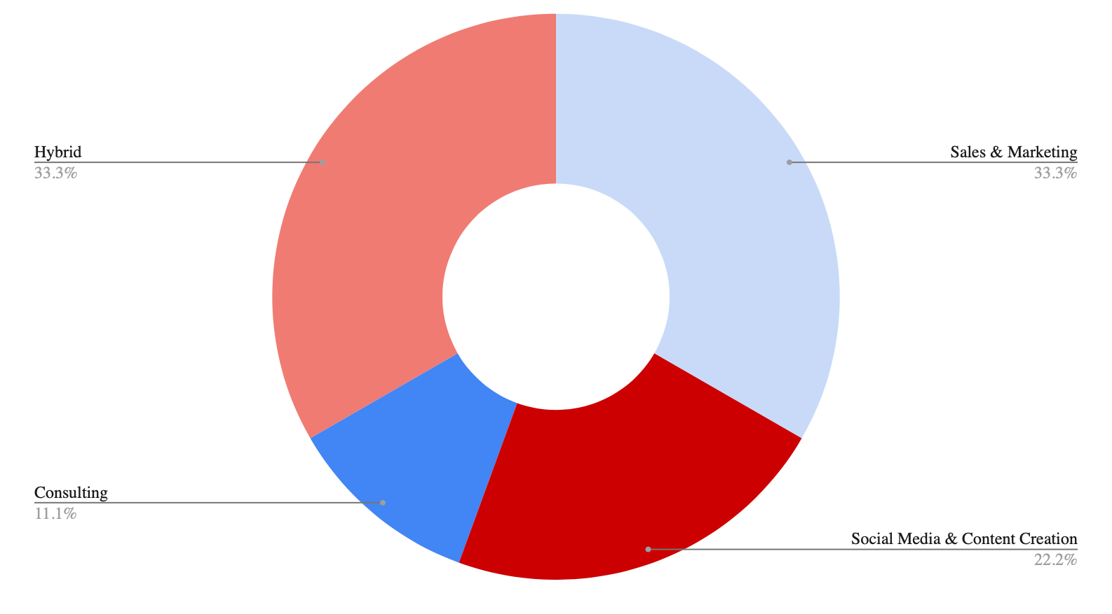
ENGLISH & MEDIA STUDIES

Hybrid companies
- ITC Limited (FMCG + Human Resources + Hospitality & Tourism)
- NIIT (Sales & Marketing + Social Media & Content Creation + Education)
- Gerson Lehrman Group, Inc. (Consulting + Human Resources)

Trends
- Hybrid roles and Sales & Marketing dominate equally (33.3% each), highlighting that English & Media Studies majors are highly attracted to multidisciplinary and market-oriented opportunities.
- Social Media & Content Creation follows at 22.2%, reinforcing the degree’s alignment with communication, media, and digital storytelling industries.
- Hybrid companies show wide diversity across FMCG, HR, Hospitality & Tourism, Consulting, and Education, indicating that English & Media Studies majors are adaptable and cross-functional, moving across creative, corporate, and service industries.

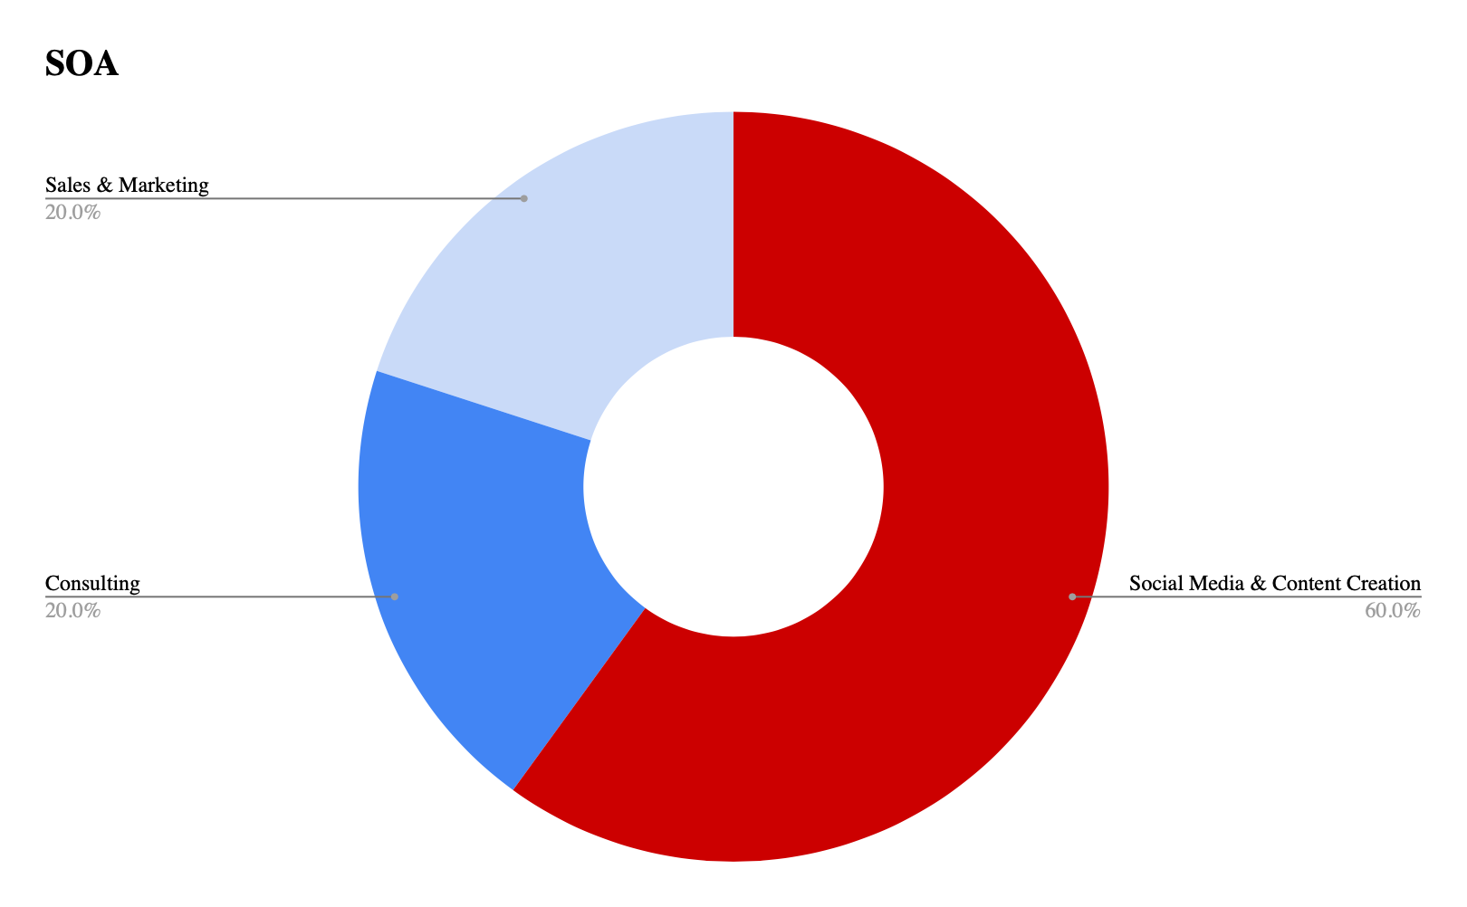
SOCIOLOGY & ANTHROPOLOGY

Trends
- The majority of graduates (60%) are placed in Social Media & Content Creation.
- Sales & Marketing (20%) and Consulting (20%) form the remaining share, showing that while students do branch into corporate-facing and analytical roles, the primary pathway is creative and digital sectors.

